Nama : Kayla Puteri Gunawan
NIM : 211331010
Kelas : 1A-TTE
Mata Kuliah : Elektronika Analog
Soal BAB 8 (buku electronic devices and circuit theory, R boylestad ) 1 – 30

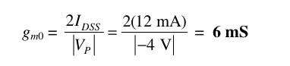
- Hitung g_{mo} untuk JFET yang memiliki parameter perangkat I_{DSS} = 12 mA dan V_{p} = -4 V.

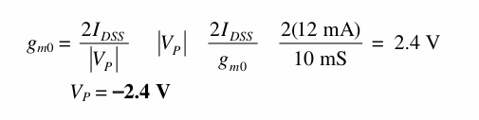
- Tentukan tegangan pinch-off dari JFET dengan g_{mo} = 10 mS dan I_{DSS} = 12 mA.

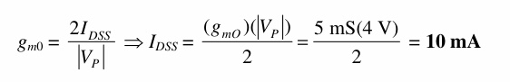
- Untuk JFET yang memiliki parameter perangkat g_{mo} = 5 mS dan V_{p} = -4 V, berapa arus perangkat pada V_{GS} = 0 V?

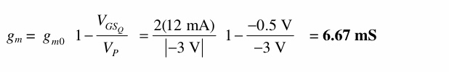
- Hitung nilai gm untuk sebuah JFET (I_{DSS} = 12 mA, V_{p} = -3 V) pada titik bias V_{GS} =-0,5 V?

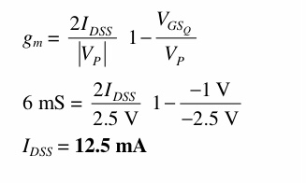
- Untuk JFET yang memiliki g_{m} = 6 mS pada V_{GSo} = -1 V, berapakah nilai I_{DSS} jika V_{p} = -2,5 V?

- JFET (I_{DSS} = 10 mA , V_{p} = -5 V) dibias pada I_{D} = I_{DSS} /4. Berapakah nilai g_{m} pada saat itu? titik bias?
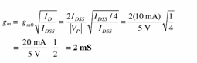

- Determine the value of g m for a JFET (IDSS = 8 mA, VP = -5 V) when biased at VGSQ = VP/4
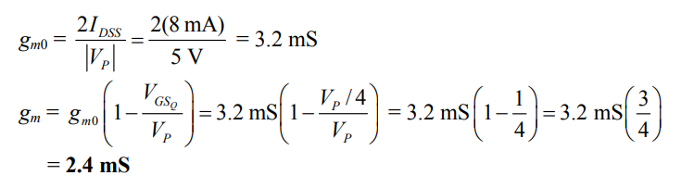

- A specification sheet provides the following data (at a listed drain-source current):
gfs = 4.5 mS, gos = 25 mS
At the listed drain–source current, determine:
a. g m .
b. r d .
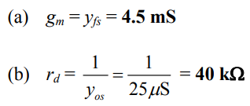

- For a JFET having specified values of gfs = 4.5 mS and gos = 25 mS, determine the device output impedance Zo (FET) and device ideal voltage gain Av(FET).
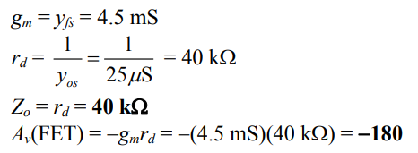

- If a JFET having a specified value of rd = 100 khas an ideal voltage gain of Av(FET) = -200, what is the value of g m?

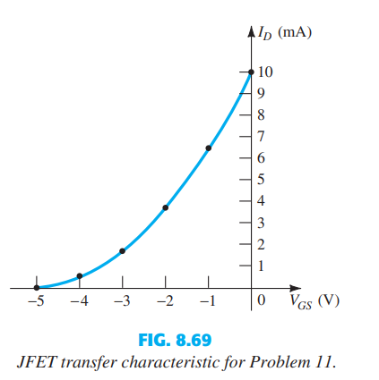
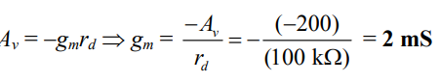

- Using the transfer characteristic of Fig. 8.69 :
a. What is the value of g m0 ?
b. Determine g m at VGS = -0.5 V graphically.
c. What is the value of g m at VGSQ = -0.5 V using Eq. (8.6)? Compare with the solution to part (b).
d. Graphically determine g m at VGS = -1 V.
e. What is the value of g m at VGSQ = -1 V using Eq. (8.6)? Compare with the solution to part (d).
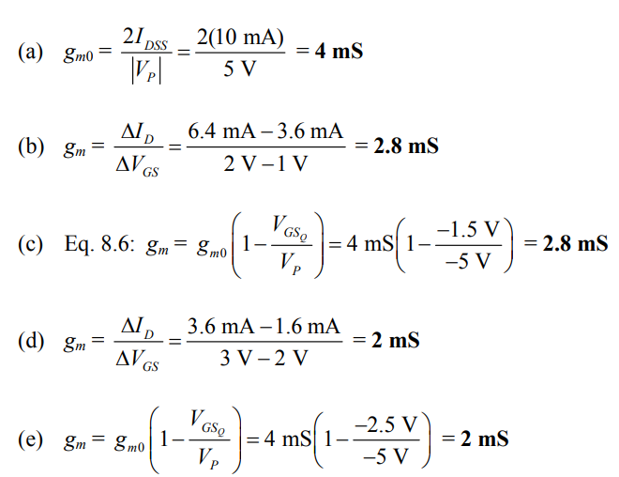

- Using the drain characteristic of Fig. 8.70 :
a. What is the value of r d for VGS = 0 V?
b. What is the value of g m0 at VDS = 10 V?
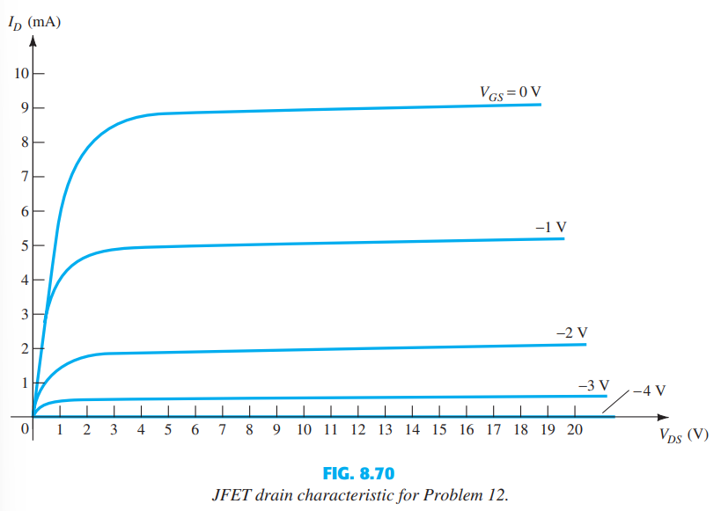
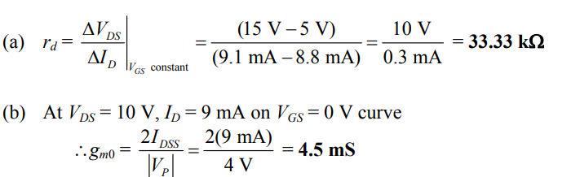

- For a 2N4220 n-channel JFET [gfs (minimum) = 750 μS, gos(maximum) = 10 μS]:
a. What is the value of gm ?
b. What is the value of rd ?
- gm = yfs = 750 μS = 0.75 mS
rd = 1/yos =1/10 μS = = 100 kΩ

- a. Plot g m versus V GS for an n -channel JFET with IDSS = 12 mA and VP = -6 V.
b. Plot g m versus I D for the same n -channel JFET as part (a).

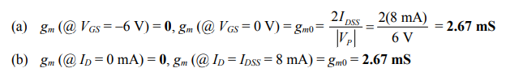

- Sketch the ac equivalent model for a JFET if gfs = 5.6 mS and gos = 15 mS.
- gm = yfs = 5.6 mS, rd = 1/yos = 1/15 μS = = 66.67 kΩ

- Sketch the ac equivalent model for a JFET if IDSS = 10 mA, VP = -4 V, VGSQ = -2 V, and gos = 25 mS.

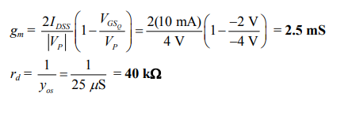

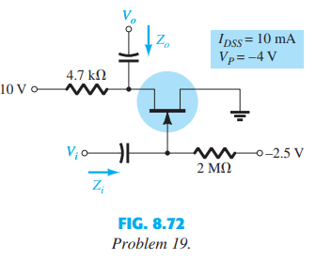
- Determine Z i , Z o , and A v for the network of Fig. 8.71 if IDSS = 10 mA, VP = -6 V, and rd = 40 k.

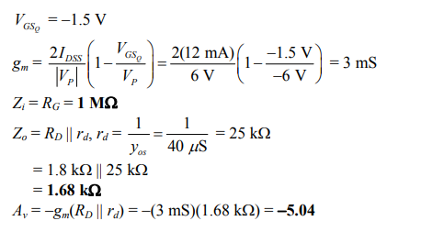

- a. Determine Z i , Z o , and A v for the network of Fig. 8.71 if I DSS and V P are one-half the values of Problems 17. This is I DSS 5 mA and V P 3 V.
b. Compare the solutions to that of Problem 17.

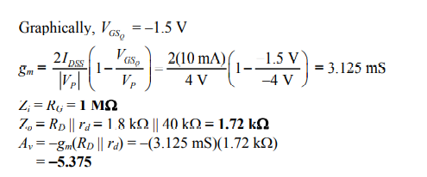

19. a. Determine Z i , Z o , and A v for the network of Fig. 8.72 if IDSS and V P are one-half the values of Problems 17. This is IDSS = 5 mA and Vp = -3 V.

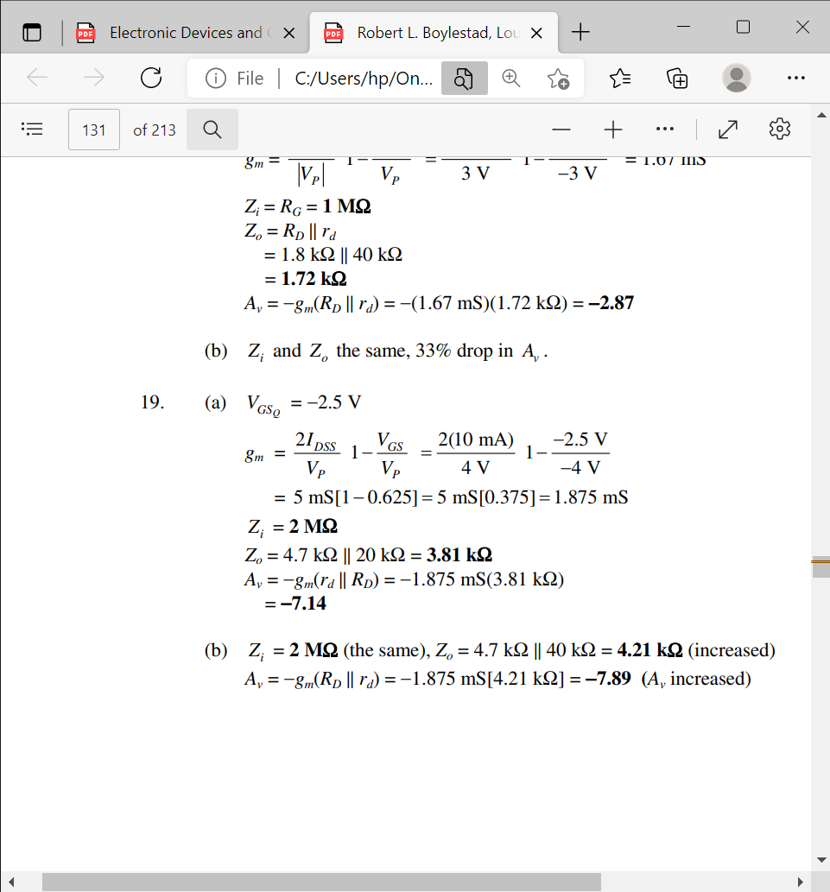

b. Repeat part (a) with rd = 40 kΩ. What was the impact on the results?

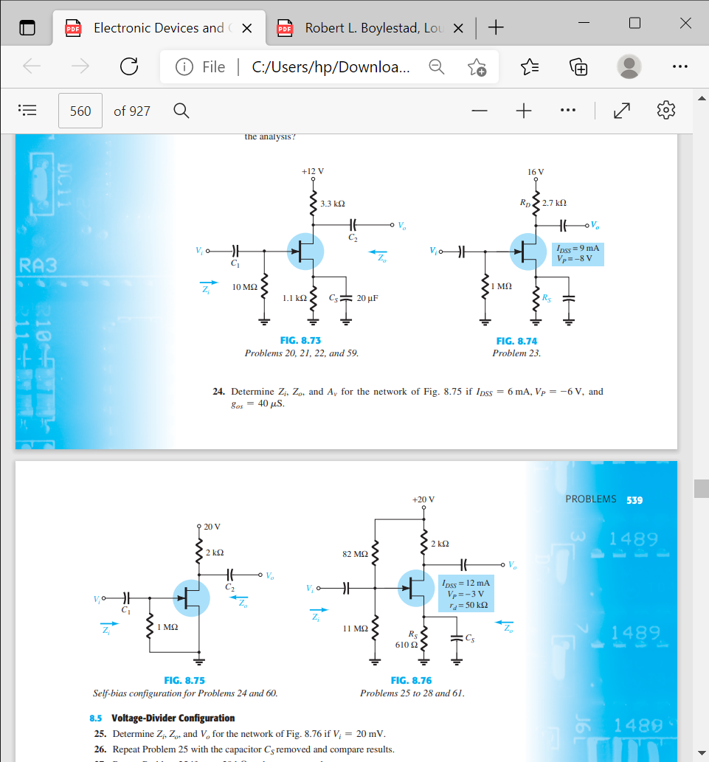
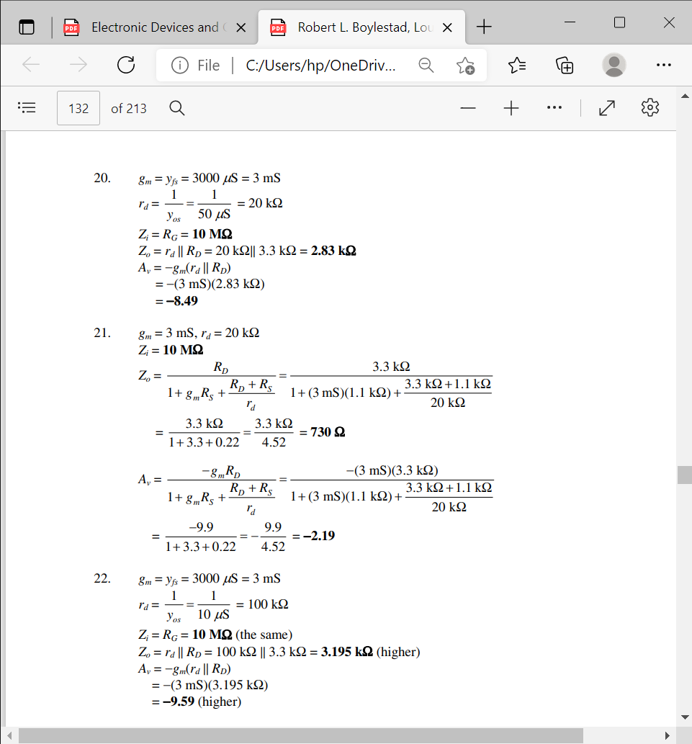
20. Determine Zi , Zo , and Av for the network of Fig. 8.73 if gfs = 3000 $μ$S and gos = 50 $μ$s.
21. Determine Zi , Zo , and Av for the network of Fig. 8.73 if the 20-$μ$F capacitor is removed and the parameters of the network are the same as in Problem 20. Compare results with those of Problem 20.
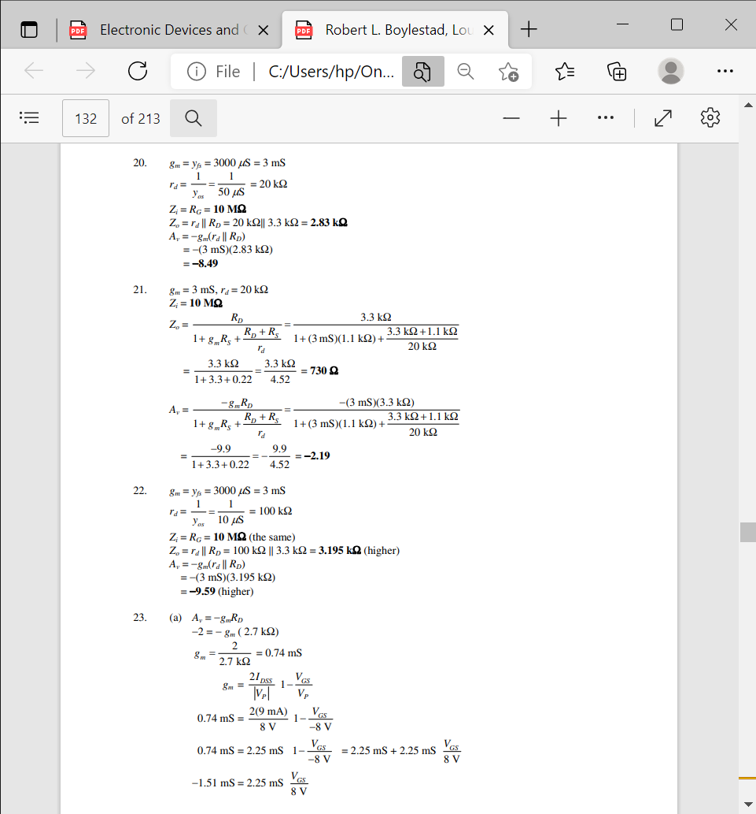

22. Repeat Problem 20 if gos is 10 $μ$S. Compare the results to those of Problem 20.
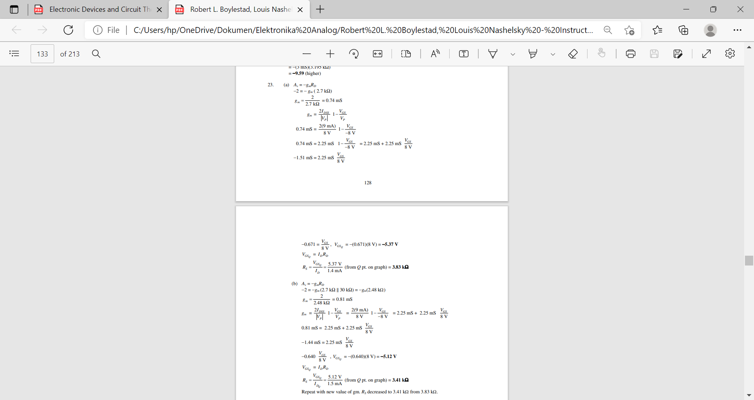

23. a. Find the value of RS to obtain a voltage gain of 2 for the network of Fig. 8.74 using
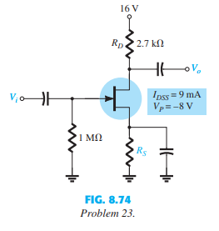
rd = ∞ Ω

b. Repeat part (a) with rd = 30 kΩ. What was the impact of the change in rd on the gain
and the analysis?

24. Determine Zi , Zo , and Av for the network of Fig. 8.75 if IDSS = 6 mA, VP = -6 V, and
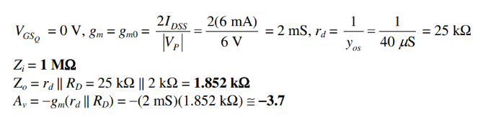
gos = 40 $μ$S

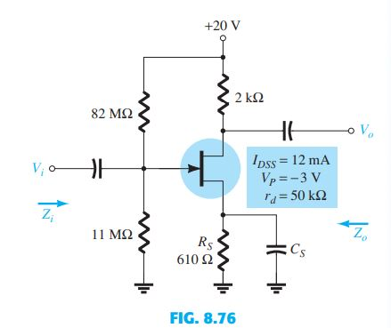
25. Tentukan $Z_{i}$, $Z_{0}$, dan $V_{o}$untuk jaringan pada Gambar 8.76 jika $V_{i}$= 20 mV.
Jawab:
V = 0,95 V, $g_{m}$(masalah 23) = 5,47 mS
$Z_{i}$ (sama) = 9,7 MΩ
$Z_{0}$ (dikurangi) = $r_{d}$|| RD = 20 kΩ || 2 kΩ = 1,82 kΩ
$A_{v}$ (dikurangi) = $g_{m}$($r_{d}$|| RD) = (5.47 mS)(1.82 kΩ) = 9.94
$V_{0}$ (dikurangi) = AvVi = (−9,94)(20 mV) = 198,8 mV

26. Ulangi Soal 25 dengan kapasitor I S dilepas dan bandingkan hasilnya.
Jawab
V = 0,95 V (seperti sebelumnya), $g_{m}$= 5,47 mS (seperti sebelumnya)
Zi = 9,7 MΩ seperti sebelumnya
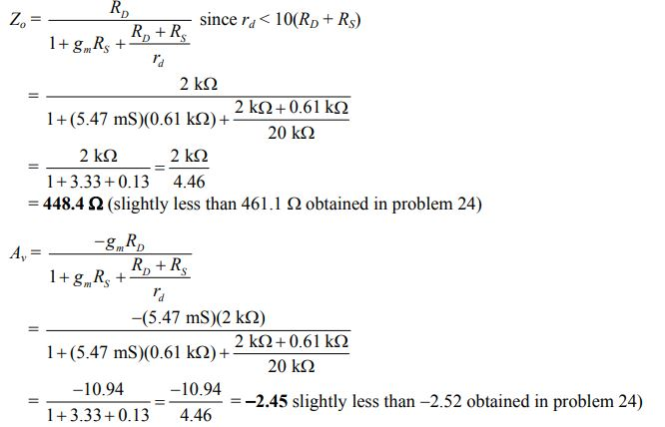

27. Ulangi Soal 25 jika $r_{d}$= 20 k dan bandingkan hasilnya.

Jawab:
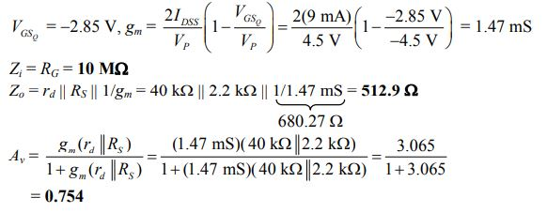

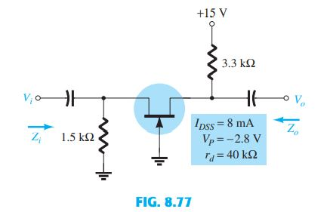
28. Ulangi Soal 26 jika $r_{d}$= 20 k dan bandingkan hasilnya. 8.6 Konfigurasi Gerbang Umum JFET.
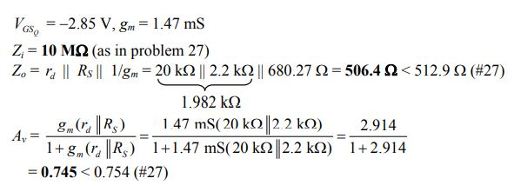
Jawab:

29. Tentukan $Z_{i}$, $Z_{0}$, dan $V_{0}$untuk jaringan pada Gambar 8.77 jika $V_{i}$= 4 mV.

Jawab:

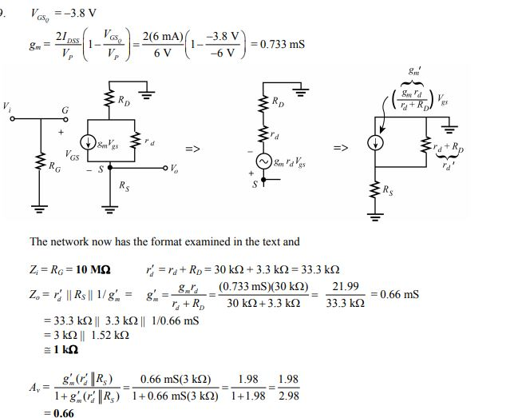

30.Ulangi Soal 29 jika $r_{d}$= 20 k dan bandingkan hasilnya.
Jawab:
V = −1.75 V, gm = 2.14 mS
$r_{d}$≥ 10RD, ∴Zi ≅ RS || 1/$g_{m}$= 1.5 kΩ || 1/2.14 mS
= 1.5 kΩ || 467.29 Ω
= 356.3 Ω
$r_{d}$≥ 10RD, ∴Zo ≅ RD = 3.3 kΩ
$r_{d}$≥ 10RD, ∴ Av ≅ gmRD = (2.14 mS)(3.3 kΩ) = 7.06
$Vo$ = AvVi = (7.06)(0.1 mV) = 0.706

